Trusted Site Certificate Renewal Notes (May 2008)

Process

Step 1: UK Servers

Generate the crt and key files
Login in as wlsadmin in the home directory type:

openssl genrsa –des3 –out ZynapHosting2010.key 2048

Please enter a passphrase this is very important and must not be left blank [note it can be anything]

then

openssl req –new –key ZynapHosting2010.key –out ZynapHosting2010.csr

- When using the second command enter the passphrase you entered above
- openssl genrsa –des3 –out UKHosting.key 1024
- openssl req –new –key UKHosting.key –out UKHosting.csr

- Please use the passphrase of <whatever but please note it down 2010 is TalentScope>
- When it prompts you for the 509 attributes please use the following:
- Country Name: US
- State or Province: New York
- Locality or City: New York
- Company: TalentScope
- Organizational Unit: just hit enter without an entry.
- Common Name: www.zynaphosting.com
- Hit enter without an entry in the remaining prompts.

Copy certificate to server

Copy the generated crt files to the server put them into the following directory:
The only 2 files copied over are the gd_bundle.crt and the zynaphosting.com.crt

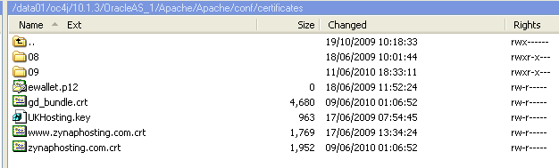

Generating the wallet

Using any machine with OpenSSL the following command was run to create the wallet file:

openssl pkcs12 -noiter -nodes -export -certfile ./ca_auth.crt -inkey ./zynaphosting.com.key -in ./may_08.crt -name 'friendly name' -nodes -noiter -out ./ewallet.p12

NOTE: may_08.crt is the name of the crt file this changes or may change in fact the lastest files of note are named: zynaphosting.com.crt and the key file ZynapHosting2010.key rather than zynaphosting.com.key

the command using the files located under Apache/Apache/conf/certificates on the UK

openssl pkcs12 -noiter -nodes -export -certfile ./gd_bundle.crt -inkey ./UKHosting.key -in ./www.zynaphosting.com.crt -name 'friendly name' -nodes -noiter -out ./ewallet.p12

this used the following files located in /data01/oc4j/10.1.3/OracleAS_1/Apache/Apache/conf/certificates

www.zynaphosting.com.crt -- the renewed certificate
gd_bundle.crt -- the cert file
UKHosting.key – UK Key the private key password TalentScope
USHosting.key – US Key password TalentScope

NOTE the wallet passwords are the same as the keys

The first is the certificate file provided, the others already existed on the system and are server specific so Savvis will probably need to help generate then for another machine.

OWM

To install the wallet owm must be run from the Oracle/bin directory via a remote X session.

Starting an x windows session

Run cygwin and type at the cmd

xinit -- -clipboard [this will open an x-windows screen]
then type xhost + [enables the remote console to connect to your pc]
then type ssh –X wlsdamin@ipaddress

cd to [on UK] /data01/oc4j/10.1.3/OracleAS_1/bin and run the owm script

To run the OWM cd to ORACLE_HOME/bin and run the owm script ./owm

Please note you need to set the full path to the ORACLE_HOME i.e /root/a/b/OracleAS_1 this is probably safest done in the owm script.

Once the GUI for the wallet manager is open select the Wallet menu item and select ‘open’ and navigate to the generated ewallet.p12 file.
This will open the generated wallet into the wallet manager. The wallet manager will ask for a password if one was set during the generation of the wallet file. In the case of the U.S. servers the wallet password is TalentScope or password for UK TalentScope: Note these are set to be the same as the key and crt files

Once opened select the Wallet menu and click the checkbox to enable the Auto Login option.
Then save this will generate the cwallet.sso file.

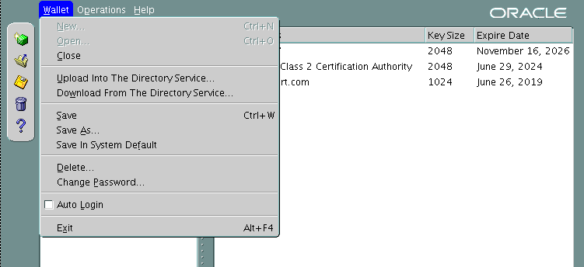

Click Save As and navigate to the ssl.wlt directory

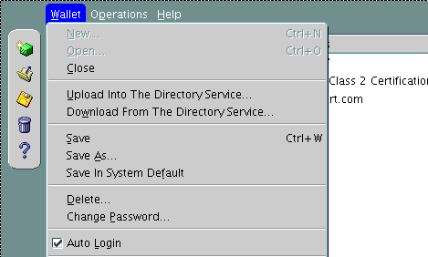

Ssl.wlt directory on the savvis UK put it under its own folder here the latest is 2010 hence zynap10
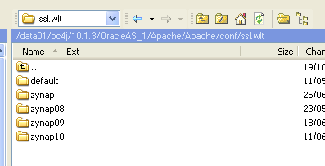

After completion the following can be seen at the file level:

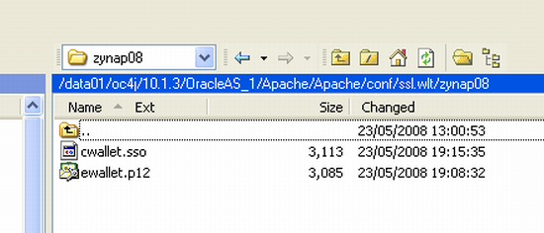
Files inside wallet

Once the files have been created the Apache ssl.conf files needs modifying. The line:
SSLWallet file:/data01/home/s603004/oc4j/10.1.3/OracleAS_1/Apache/Apache/conf/ssl.wlt/ts08

Should be added, note it points to a directory rather than an individual file. This line is added just below the SSLCipherSuite ALL: key

Extra pieces of info

If you need to verify the key matches the certificate please use the following commands

openssl x509 -noout -modulus -in server.crt | openssl md5
openssl rsa -noout -modulus -in server.key | openssl md5

The above command will give you 2 lines of data that should be the same if the key matches the certificate

openssl x509 -noout -in <certificate> -dates

The above command will tell you the expiry dates of the given certificate

